**Surgical Robotics: Designing a Specialized Baby Gastroschisis Silo Ring**

**By Benjamin Matthew Gitzinger**

**Supervised by Dr. Ann Majewicz Fey**



**Undergraduate Honors Thesis**

Presented to the Faculty of the Cockrell School of Engineering of

The University of Texas at Austin

In Partial Fulfullment

Of the Requirements

For the Degree of

**Bachelor of Science in Mechanical Engineering**

**The University of Texas at Austin**

**May 2022**

Acknowledgments

I would first like to thank Dr. Ann Majewicz Fey for guiding me throughout the making of this report. I came to her at the start of the Fall 2021 semester asking for ideas for my research topic, and within days of meeting her, she helped me find a project and agreed to be my primary supervisor. She has been incredibly kind, supportive, and flexible.

I would like to thank Dr. Nicholas Fey as well. He was one of the first instructors for an in-person class after the start of the COVID-19 pandemic. His kind words and encouragement helped me gain confidence and strength in the classroom again. I would also like to thank him for agreeing to be my second reader.

I would like to thank the students of the HeRo Lab for being so supportive. It has been nice to see friendly faces throughout the year as I came in to work on my project. They were always willing to help when I asked for it. I am amazed at the important work that they accomplish, and I wish them the best in their studies in the years to come.

I would like to thank Orren Shachaf for her work on the Baby Silo project in the summer of 2021. Prior to my joining the project, she had already assembled much of the circuitry of the active control board. She also provided me with instructions and advice on how to mix silicone rubber and prepare it for insertion into molds. Her work served as an invaluable starting point and saved me many hours of trial and error.

I would like to thank Jared Allison for his help in 3D printing the molds that I had designed. He was willing and incredibly eager to work with me to help the final product come out as nicely as possible.

Finally, I would like to thank my friends and family for offering me support and comfort when I need it most. They encourage me to believe that I can do anything.

Table of Contents

Acknowledgments i

Table of Contents iii

List of Figures and Tables v

Abstract vii

1 INTRODUCTION 1

1.1 Disease State 1

1.2 Current Solutions 2

1.3 Goal of this Project 3

2 DESIGN AND SIMULATION 5

2.1 Considerations of Design and Previous Work 5

2.1 Simulations 6

2.1 Simulation Results 7

3 PHYSICAL TESTING 10

3.1 Device Creation 10

3.2 Programming the Control Board 13

3.2.1 Pulse Width Modulation 13

3.2.2 PID Development 14

3.3 Testing Procedure 16

3.4 Results 16

4 CONCLUSIONS AND RECOMMENDATIONS 19

References 21

List of Figures AND TABLEs

Figure 1. Infant Suffering from Gastroschisis. 1

Figure 2. Staged Reduction of Intenstines Using a Silo. 2

Figure 3. Spring Loaded Baby Silo. 3

Figure 4. Ring Model of Existing Devices in SOLIDWORKS. 6

Figure 5. Vertical Constraint Ring Model in SOLIDWORKS. 7

Figure 6. Displacement Plot for a Helical Ring Model. 7

Figure 7. Theoretical Dimension Results. 8

Figure 8. Theoretical Dimension Results (Differential). 8

Figure 9. Mold Parts for Ring Creation. 10

Figure 10. Dragon Skin Material and Vacuum Pump. 11

Table 1. Color Identification of Ring Devices. 11

Figure 11. Injection of Silicone Rubber into the Mold. 11

Figure 12. Oxygen Tubing Insertion. 12

Figure 13. Completed Devices Ready for Testing. 12

Figure 14. Active Control Board Components. 13

Figure 15. Example of PWM Signals and Counter Behavior. 14

Figure 16. Real-time Response to Pressure Set Points Using a PID Controller. 15

Figure 17. Ring Device and EM Sensors Prior to Testing. 16

Figure 18. Trends of Displacement based on Constraint Level. 17

Figure 19. Change in Displacement vs. Constraint Level (Differential). 18

Figure 20. Potential New Ring Design. 19

Abstract

Gastroschisis is a congenital birth defect in which an infant is born with a hole in its abdomen, allowing its internal organs to rest outside of the body. Medical solutions currently exist to resolve this problem, such as primary fascial closure, sutureless surgery, and inserted silos for the staged reduction of the protruding organs. However, treatment for this defect can lead to long hospital stays and exorbitant medical bills. In an attempt to create a new method of treatment to reduce these negative effects, testing was conducted to evaluate the feasibility of an inflatable silo ring that could actively close the abdominal defect through inflation. Variations of this theoretical device were first simulated in SOLIDWORKS to discover what designs were most well suited for abdominal insertion. Selected designs were subsequently verified through physical prototyping and measurement.

INTRODUCTION

## Disease State

Gastroschisis is a birth defect in which infants are born with a hole through the entire thickness of their abdominal wall. Depending on the size and severity of the defect, some or all of the digestive tract and other organs may be eviscerated, requiring reduction of the protruding organs and subsequent placement back inside of the abdomen.

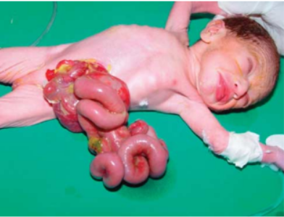

1. Infant Suffering from Gastroschisis (Hasheesh & Elhalaby, 2011)

The most common congenital abodominal wall defect, Gastroschisis is estimated to occur between four and five times every ten thousand live births (Kunz et al., 2013). While this condition may seem serious, in recent decades, survival is considered to be well over 90% (Kunz et al., 2013). However, the mean hospital length of stay (LOS) ranges between 35 and 41 days, costing parents between $155,629 and $172,000 on average (Kunz et al., 2013). Ideally, hospital stays and bills can be reduced by focusing on the development of technology that can quickly and efficiently close the defect without creating additional health complicaitons.

## Current Solutions

For many infants, the defect is not particularly serious and may often be closed within the first day of life. When protruding organs are minimal and there is sufficient room in the abdomen, surgeons can place the intentines back inside the neonate and immediately proceed with the primary closure. Occasionally, bowels require preclosure protection and handling, whether that be through wrappings or silos (Weinsheimer et al., 2008).

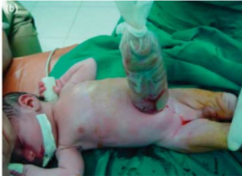Silos are bags used to house protruding intestinal material and guide them back into the body. Once placed in the tubing, the silo is hung above the baby so that gravity works to help pull the organs back inside the abdomen. Tying the silo at the current tip of the intenstines once or twice a day can also help with active reduction of the eviscerated bowels (Sherif, 2019).

1. Staged Reduction of Intenstines Using a Silo (Hasheesh & Elhalaby, 2011)

In previous decades, silos and similar bags for placement of the intestines had to be sutured into the fascia surrounding the defect. More recently, spring loaded silos (SLS) have been created, using a stronger base ring that can be placed under the stomach fascia without the need for stitches or surgery.

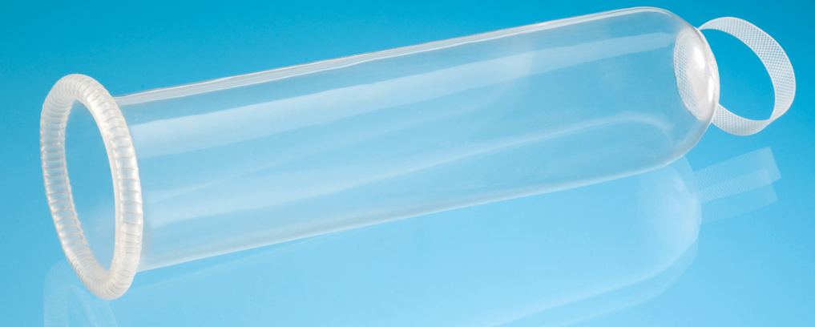

1. Spring Loaded Baby Silo (“Silicone Silo Bags”, n.d.)

Silos are used to slowly re-insert the intestines and organs back inside the baby until a primary closure operation can be completed. The vast majority of the time, in around 80% of procedures, this final operation is completed through direct fascial closure (Weinsheimer et al., 2008). However, other procedures can be employed. Some surgeons prefer to use skin flap closures or mass closures to suture the defect closed to avoid disturbing the fascia. Approximately 9% of the time, the primary closure is completed without the use of sutures at all (Weinsheimer et al., 2008). The umbilical cord of a child, if held in place, can heal over the defect (Ogasawara et al., 2009). While this occasionally leads to small umbilical hernias in the child’s abdomen, these disruptions eventually heal on their own.

## Goal of this Project

This project was conducted in an attempt to develop a new solution for the repair of gastroschisis defects that would reduce healing time and reduce the need for extensive primary fascial closure procedures. The initial idea under investigation in Dr. Fey’s HeRo lab is a baby silo like the one shown in Figure 3, except where the ring could be inflated with air. If the expanded ring of this baby silo was inserted and sutured into the neonate’s fascia, over time the amount of air pressure in the ring could be reduced and its diameter would shrink. As the ring shrank, the contracting device would pull the surrounding tissue closer together, slowly reducing the size of the defect. This would help the tissue of the child heal more organically than with fascia suturing for the primary closure. The active pulling of the tissue could also potentially offer an increase in speed from what baby silos and sutureless solutions typically demonstrate.

# DESIGN AND SIMULATION

## Considerations of Design and Previous Work

For this active baby silo design, the ring base would ideally expand outwards but not upwards when inflated. Movement of the silo ring during inflation should be parallel to the plane of the baby’s stomach. Growth in other directions, should be limited to avoid interference with internal structures and tissues within the abdomen. The outward expansion of the general ring shape will from this point forward be referred to as the “nominal diameter.” The diameter of the cross section of the ring will from this point be referred to as the “meriodional diameter.” The ideal ring design would have large nominal expansion accompanied by minimal meriodinal expansion.

Dr. Fey’s lab had already produced a number of sample ring devices using a mold with a metal insert that made the ring hollow and able to be inflated. Rings created with this mold had approximately a 6.5mm uninflated meriodinal diameter and a 36.5mm uninflated nominal diameter. A single raised helix wrapped around the length of the ring, similar to the design of the ring of the SLS in Figure 3. The raised helix composed approximately 57% of the surface area of the device, meaning this design was “57% constrained.” The design of the existing ring was modeled in SOLIDWORKS in Figure 4 below.

Given that there were no molds of other ring designs for compairson, there was no way of ascertaining with existing tools what would be the optimal construction of the silo rings. However, new molds could be printed and used if it was determined that geometric differences in the rings would yield different behaviors. SOLIDWORKS simulations could be conducted to estimate the effects of geometry on the geometric properties of the rings upon inflation. With these tests, the ideal constraint level yielding the lowest meriodional expansion could be theoretically determined, and physical prototypes of that device could be created.

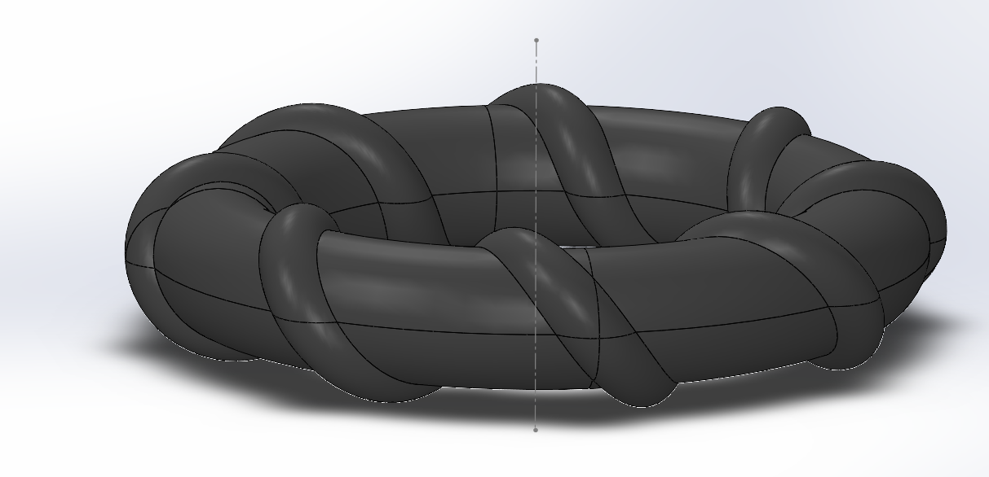

1. Ring Model of Existing Devices in SOLIDWORKS

## Simulations

Nine different helical designs, all with varying constraint levels, were produced as models in SOLIDWORKS. Overall, the helical design would actually work quite well for the purpose of suturing it to human tissue given that the grooves between the helix could serve as a guide for the thread. Other designs for potential simulations were considered, but few also had this implementation advantage. Five designs with simple vertical constraints were also modeled so that any effects of the design itself could be recorded. A fully constrained and un-constrained ring were also created for reference during testing.

Using a non-linear solver in the simulation SOLIDWORKS add-in, the ring was subjected to a growing internal pressure over a period of 10 seconds. The pressure grew linearly from 0psi to 20psi. Displacement measurements were then taken across the width of the whole ring for the nominal measurements and across the cross section for the meriodional measurements.

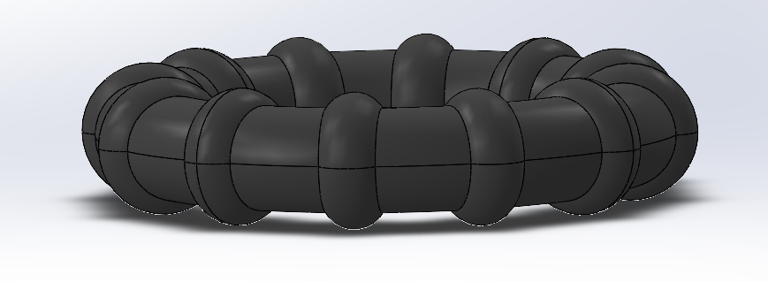

1. Vertical Constraint Ring Model in SOLIDWORKS

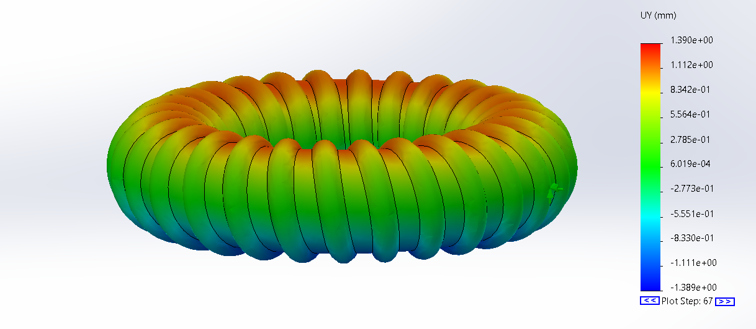

1. Displacement Plot for a Helical Ring Model

## Simulation Results

From the displacement plots of the the 16 different models, the ratio between meridional and nominal diameter was calculated and plotted as a function of the constraint level (Figure 7). The ratio in the changes of these diameters was also plotted (Figure 8).

1. Theoretical Dimension Results
2. Theoretical Dimension Results (Differential)

Both graphs predict that additional constraints cause the meridional to nominal dimater ratio to decline. When comparing the ratios of the changes in meridional and nominal diameter, the helical and vertical constraint designs behave extremely similarly. However, the helical designs can be seen to perform better than their vertical constraint counterparts for most constraint levels, particularly in Figure 7, so this would be the selected design going forward.

Most interesting, however, is the relative minimum present for both designs around the 75-80% constraint level. The ideal baby silo ring would have the lowest ratio possible, so a minimum in the plotted figures is a promising constraint level for the feasibility of the active baby silo design. However, one complication is that there are no data points between the recorded minimum and a fully constrained ring. Models with higher constraint levels in this range had been impossible to create in SOLIDWORKS. Since the constraints were so close together, they would merge and change the structure of the ring itself. Therefore, any test of the performance of a ring with a constraint level between 75% and 100% would need to be done with a physical prototype.

As an attempt to verify these theoretical results with actual experimentation, three different molds were created at the 50%, 75%, and 90% constraint levels. They represented a ring at a low constraint level, a ring at the theoretical minimum level, and a ring in the range of constraints that could not be modeled in a simulation. These three points could offer data that would hopefully characterize and verify the charts obtained through simulation.

PHYSICAL TESTING

## Device Creation

Three sets of molds were created for ring production. Each mold consists of a top half and a bottom half. The top half has a variety of holes to allow trapped air bubbles within the setting silicone rubber to escape. An insert is placed in between the two halves to ensure that the ring is hollow and able to pass air through it. The two halves should be screwed together and clamped down to ensure the rubber takes the proper shape.

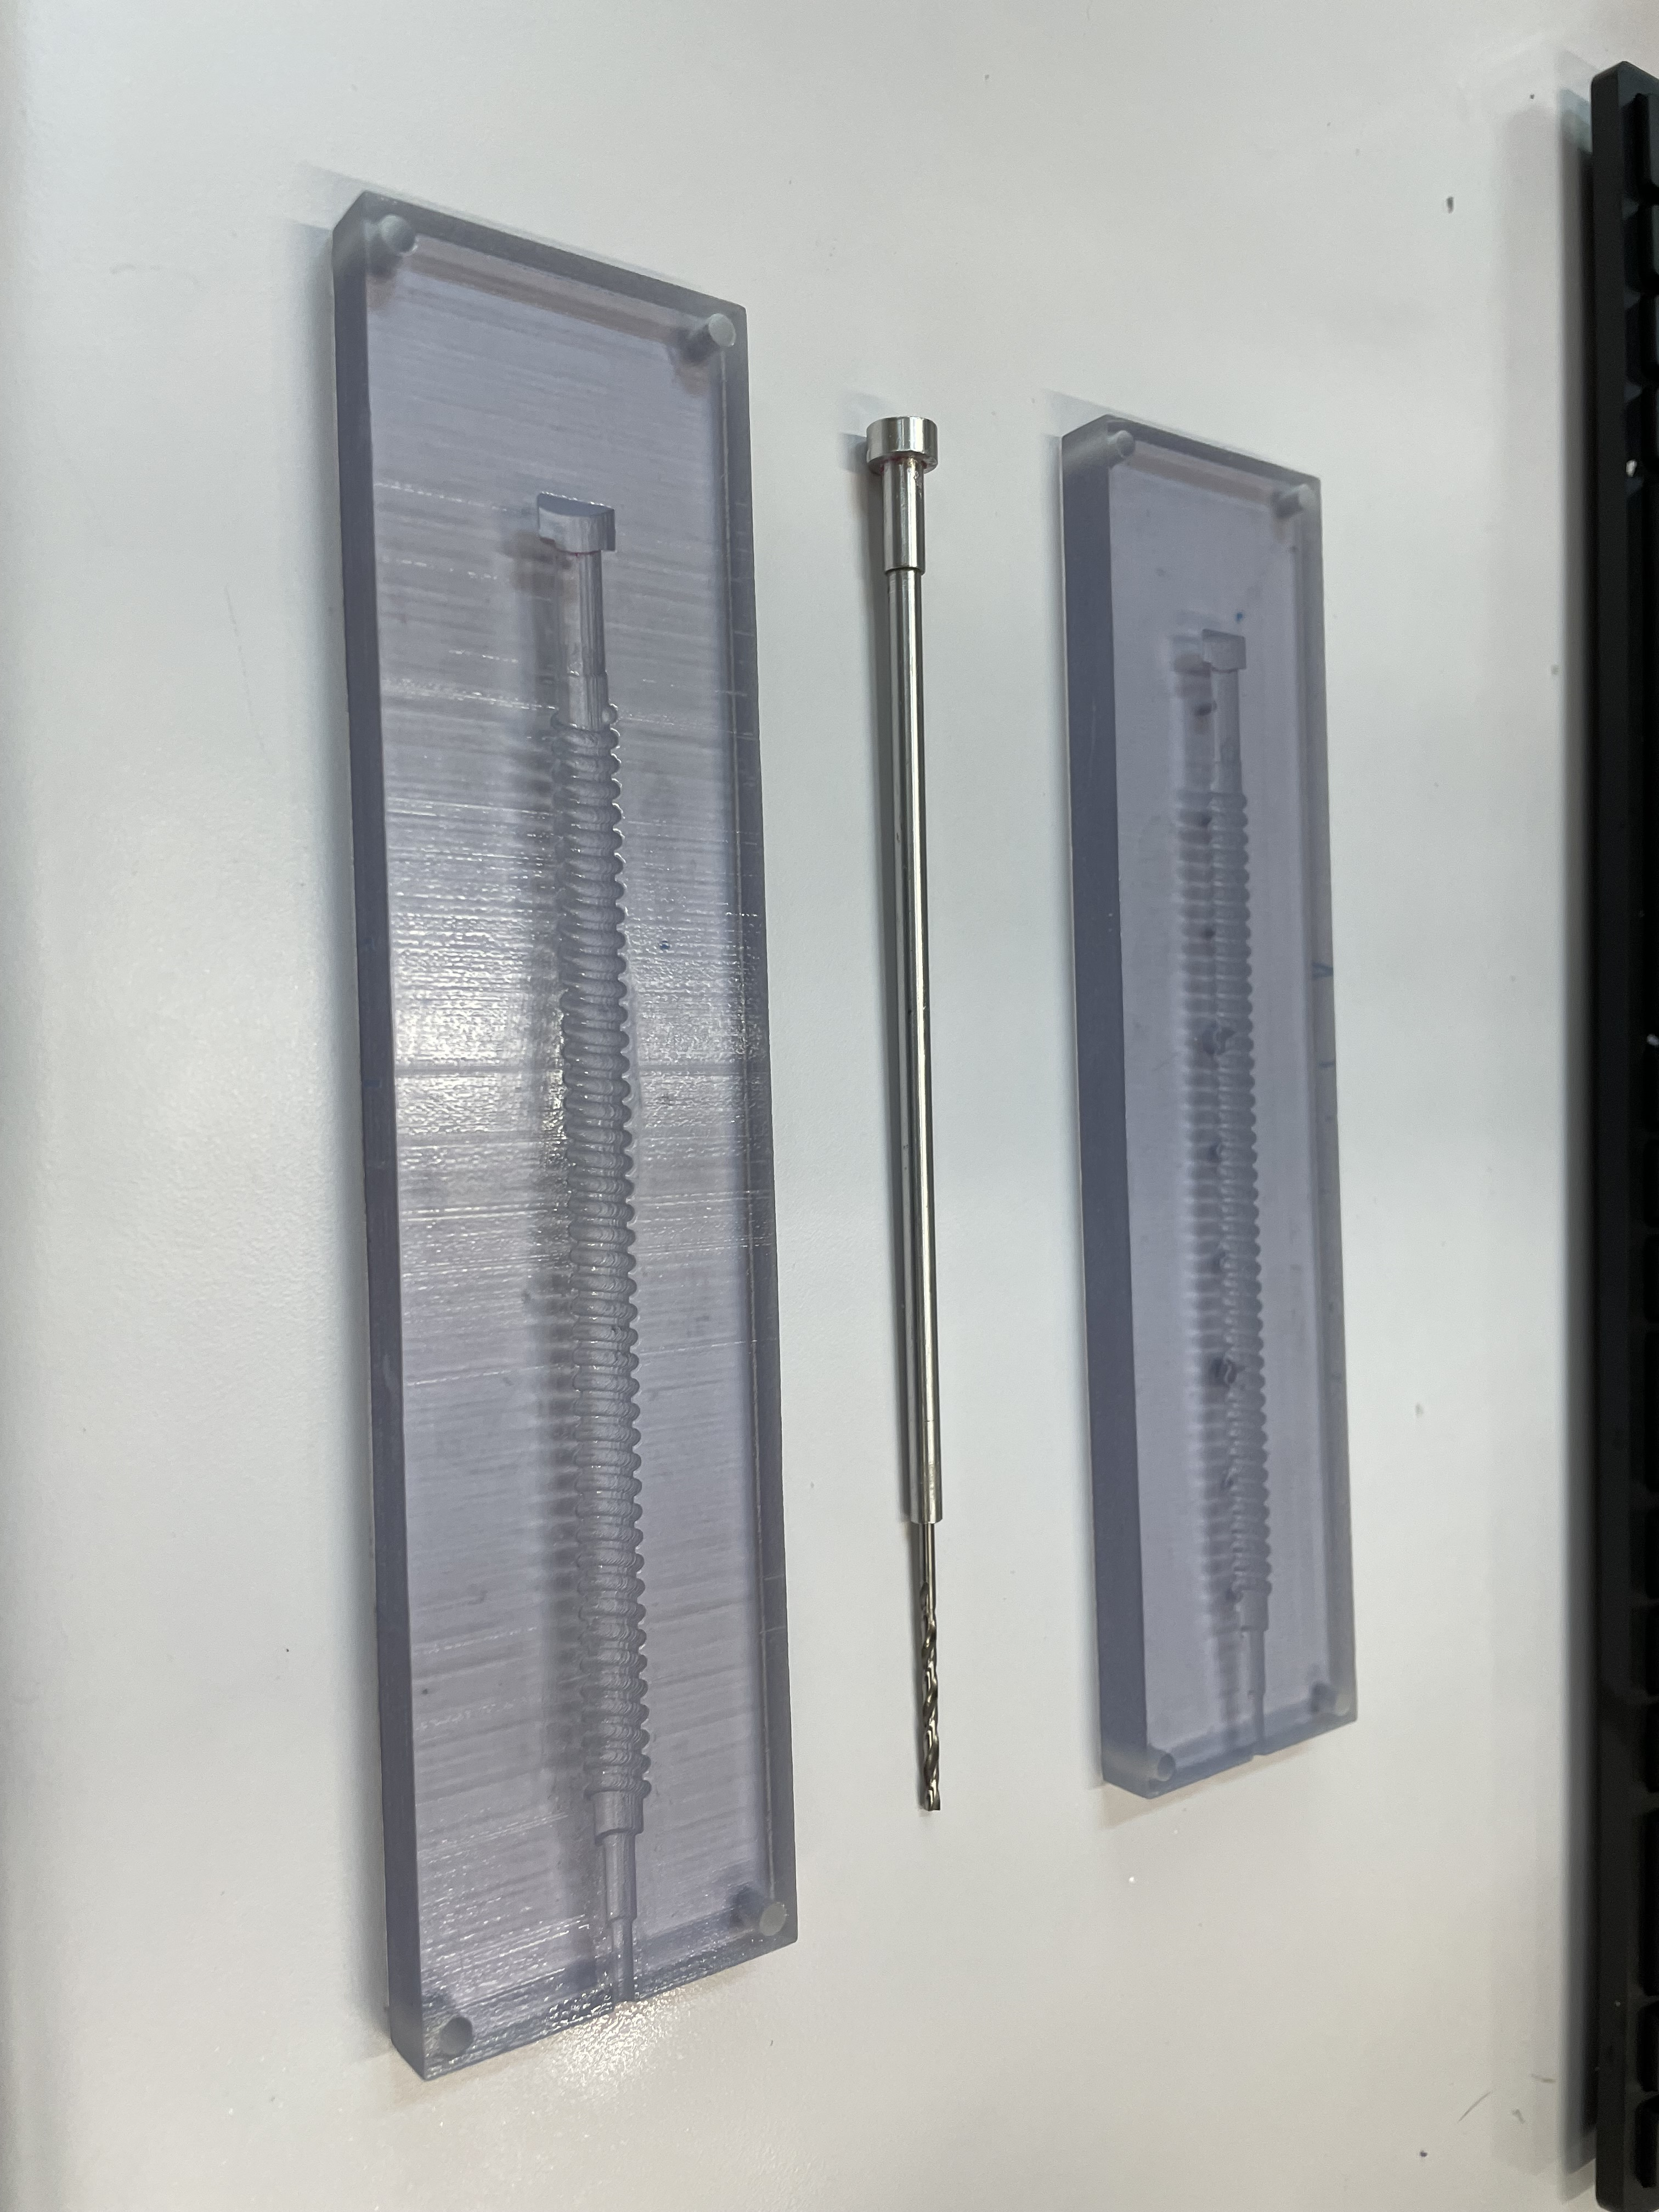

1. Mold Parts for Ring Creation

The rings are made of Dragon Skin 20 Platinum Cure Silicone Rubber, which for the purposes of storage, is kept in two separate containers. Mixing the two materials together in equal parts yields a viscous gel like substance that will begin to set in a matter of minutes. After placing the mixture in a vacuum chamber to remove internal air impurities, it can be injected into the mold with a syringe and left overnight (Figure 11). Three different inserts of varying thicknesses were used at each constraint level, creating a total of 9 ring devices for experimental testing.

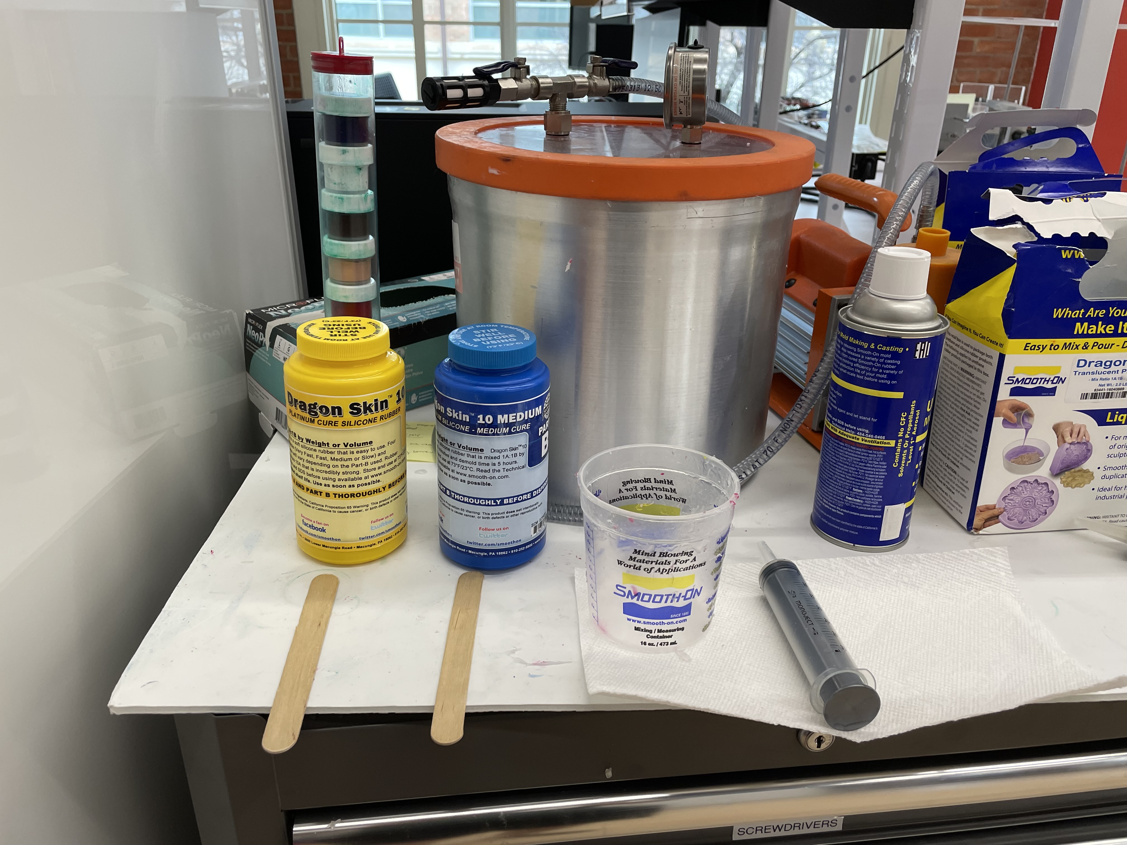

1. Dragon Skin Material and Vacuum Pump
2. Color Identification of Ring Devices

|  |  |  |  |
| --- | --- | --- | --- |
| Insert Size | 50% | 75% | 90% |
| 4.75mm | Red | Black | Yellow |
| 4.46mm | Brown | Green | White |
| 3.18mm | Purple | Blue | Peach |

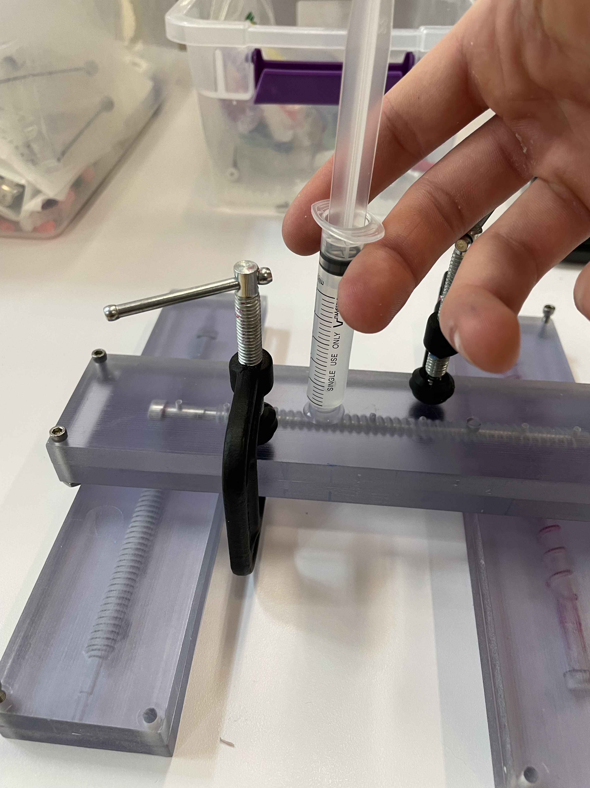

1. Injection of Silicone Rubber into the Mold

After the devices were dry and removed from their molds, they needed to be prepared for inflation. A small incision was made near the tip of the device, just large enough to fit the head of a t-junction nozzle for air tubing. Once the tubing was secure, the ring could be closed, and eventually glued into place using Sil-Poxy, a silicone rubber adhesive. After all connections were secured and holes covered, the fleet of testing devices was ready for experimentation.

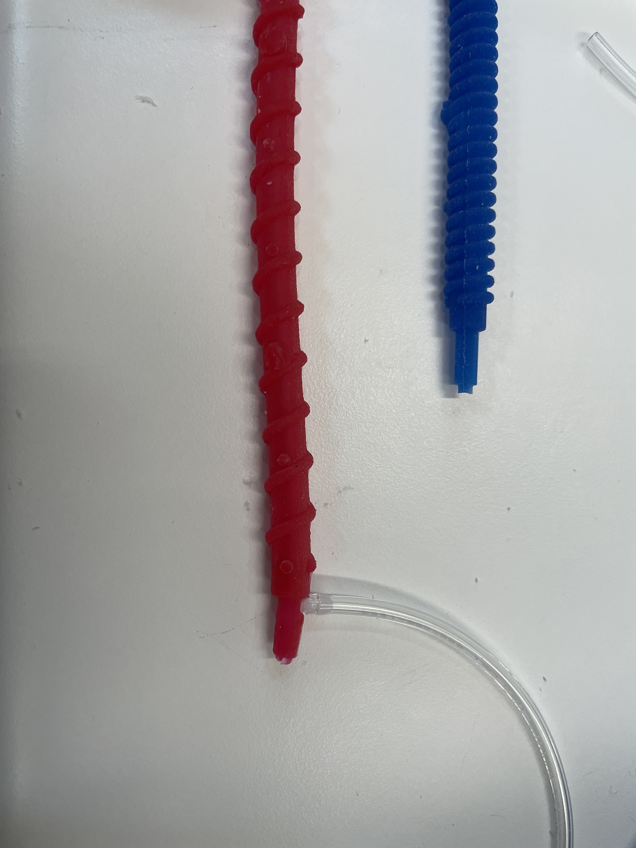

1. Oxygen Tubing Insertion

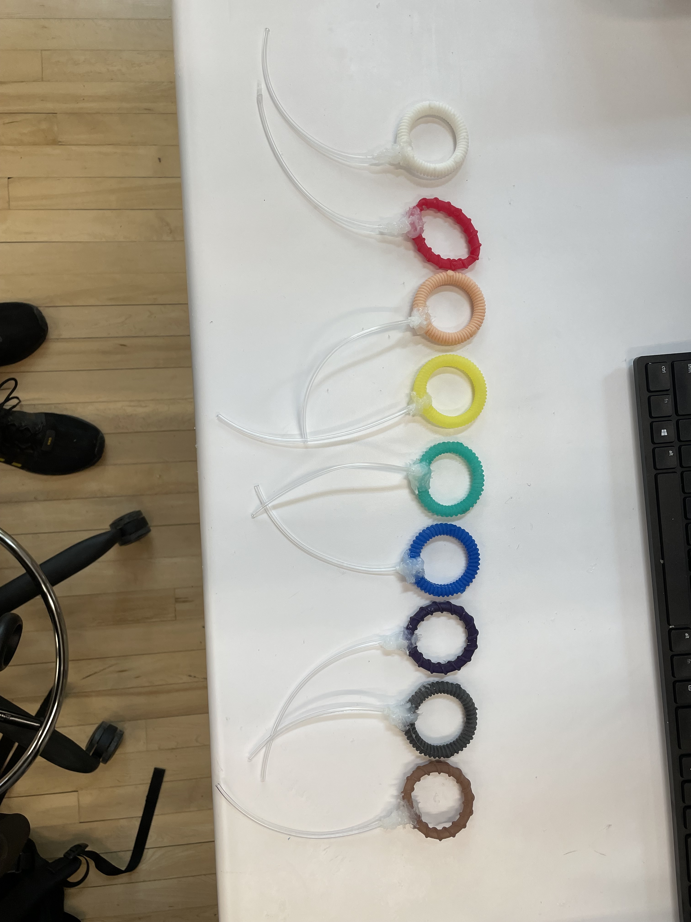

1. Completed Devices Ready for Testing

## Programming the Control Board

Now that the rings were ready for testing, a system needed to be created that would enable air to reliably be pumped into the ring at reasonable pressures. The active control board kit that was already mostly set up in the HeRo lab could be adapted for this purpose.

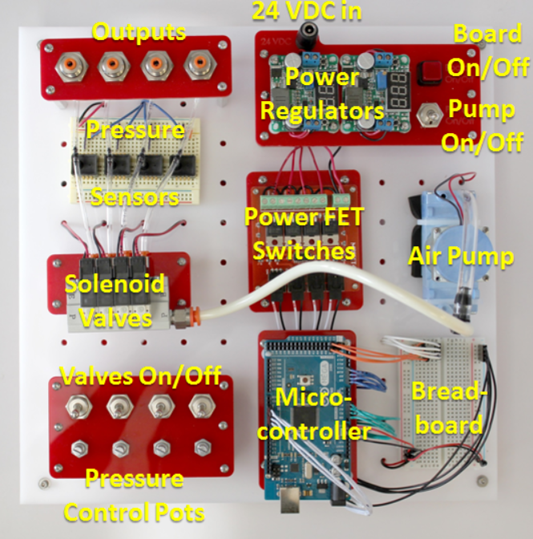

1. Active Control Board Components

### Pulse Width Modulation

One issue with the circuitry board at the start of this project was that it only could pump air at one speed. The pump was effectively either on or off. Because of this, it was easy to overinflate and potentially damage the devices if one wasn’t careful. One way to prevent this was to connect a potentiometer to adjust the pulse width modulation (PWM) signals being sent to the solenoid valves operating the air pump. PWM effectively is an analog output created by timed digital square waves. By changing a counter value, the microcontroller knows to send an active signial for a certain percentage of the time, known as a “duty cycle.” If the potentiometer could be linked to the analog input received from the potentiometer, the duty cycle could be regulated. However, an open loop system of continuous input with no feedback would also be dangerous for the integrity of the ring devices. Therefore, a PID controller was developed to monitor the PWM output.

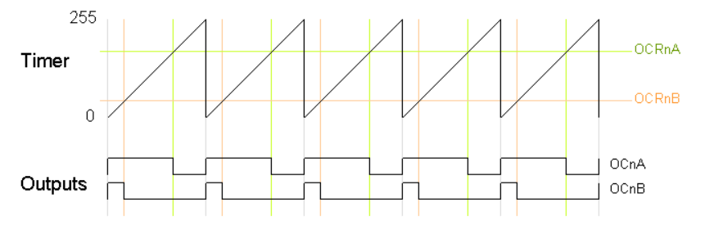

1. Example of PWM Signals and Counter Behavior (“Secrets of Arduino PWM”, 2022)

### PID Development

Using a sensor to monitor the performance of a system, the incoming data can be read and interpreted to update the output of the system as part of a closed loop controller. A Honeywell ASDX 15psi sensor was connected to the circuit, attached in parallel to the tubing connected to the ring devices. Because of this conncection, the pressure in the ring would be the same as the pressure measured by the sensor.

An equation was created to relate the OCRnA counter from Figure 15 to the data obtained by the pressure sensor, taking into account the inverse relationship between pressure readings and desired PWM output. The higher the pressure reading, the smaller the PWM needed to maintain that pressure. Therefore, the following equation was incorporated in the Arduino code:

$OCRnA=ICRn*(1- \frac{u\left(t\right)}{p\left(t\right)})$ (Eqn. 1)

Here, p(t) represents the analog input from the potentiometer creating the desired setpoint pressure, and ICRn represents the full counter value that PWM uses to determine its duty cycle. The u(t) term represents the output from a PID controller, an equation that uses the error, e(t), between the setpoint and the values recorded by the sensor to calculate the system’s next output.

$u\left(t\right)=K_{p}e\left(t\right)+K_{i}\int{e\left(t\right)dt}+K_{d}\frac{de}{dt}$ (Eqn. 2)

The parameters for the PID controller, Kp, Ki, and Kd, were determined from the Ziegler-Nichols tuning method. Equations 1 and 2 were re-calculated every millisecond to ensure as smooth of an operation as possible for the pump to hopefully yield the desired output continuously. Figure 16 shows how the system was able to adapt and respond to pressure readings to maintain a near constant pressure around a desired setpoint, even if this value was changing over time.

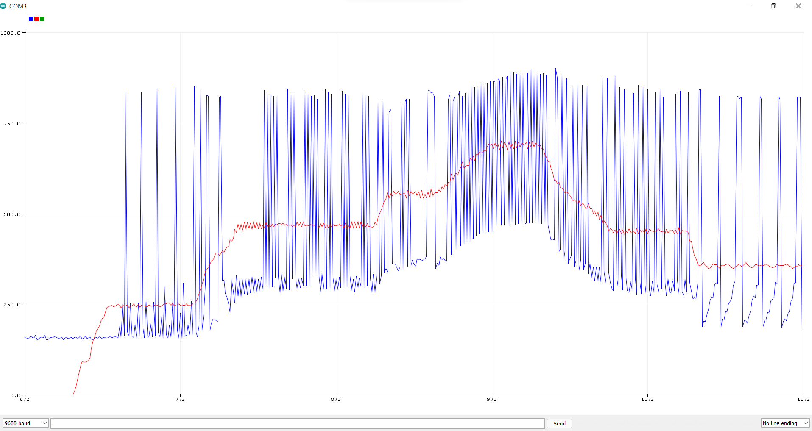

1. Real-time Response to Pressure Set Points Using a PID Controller

## Testing Procedure

For each ring, electromagnetic (EM) sensors would be held against the rings in a variety of locations, both across the meridional, cross-sectional diameter and the full, nominal diameter of the rings. Measurements were taken at a negligible pressure for a baseline, and then again once when the ring was inflated close to the maximum pressure that the ring could tolerate before failure. Three measurements of each diameter would be taken at both pressures, yielding a total of 12 measurements. When the EM sensors were activated for a measurement, dozens of frames were recorded, so each measurement was itslef an average. This helped to diminish effects of noise and error from the pump on the data collection process.

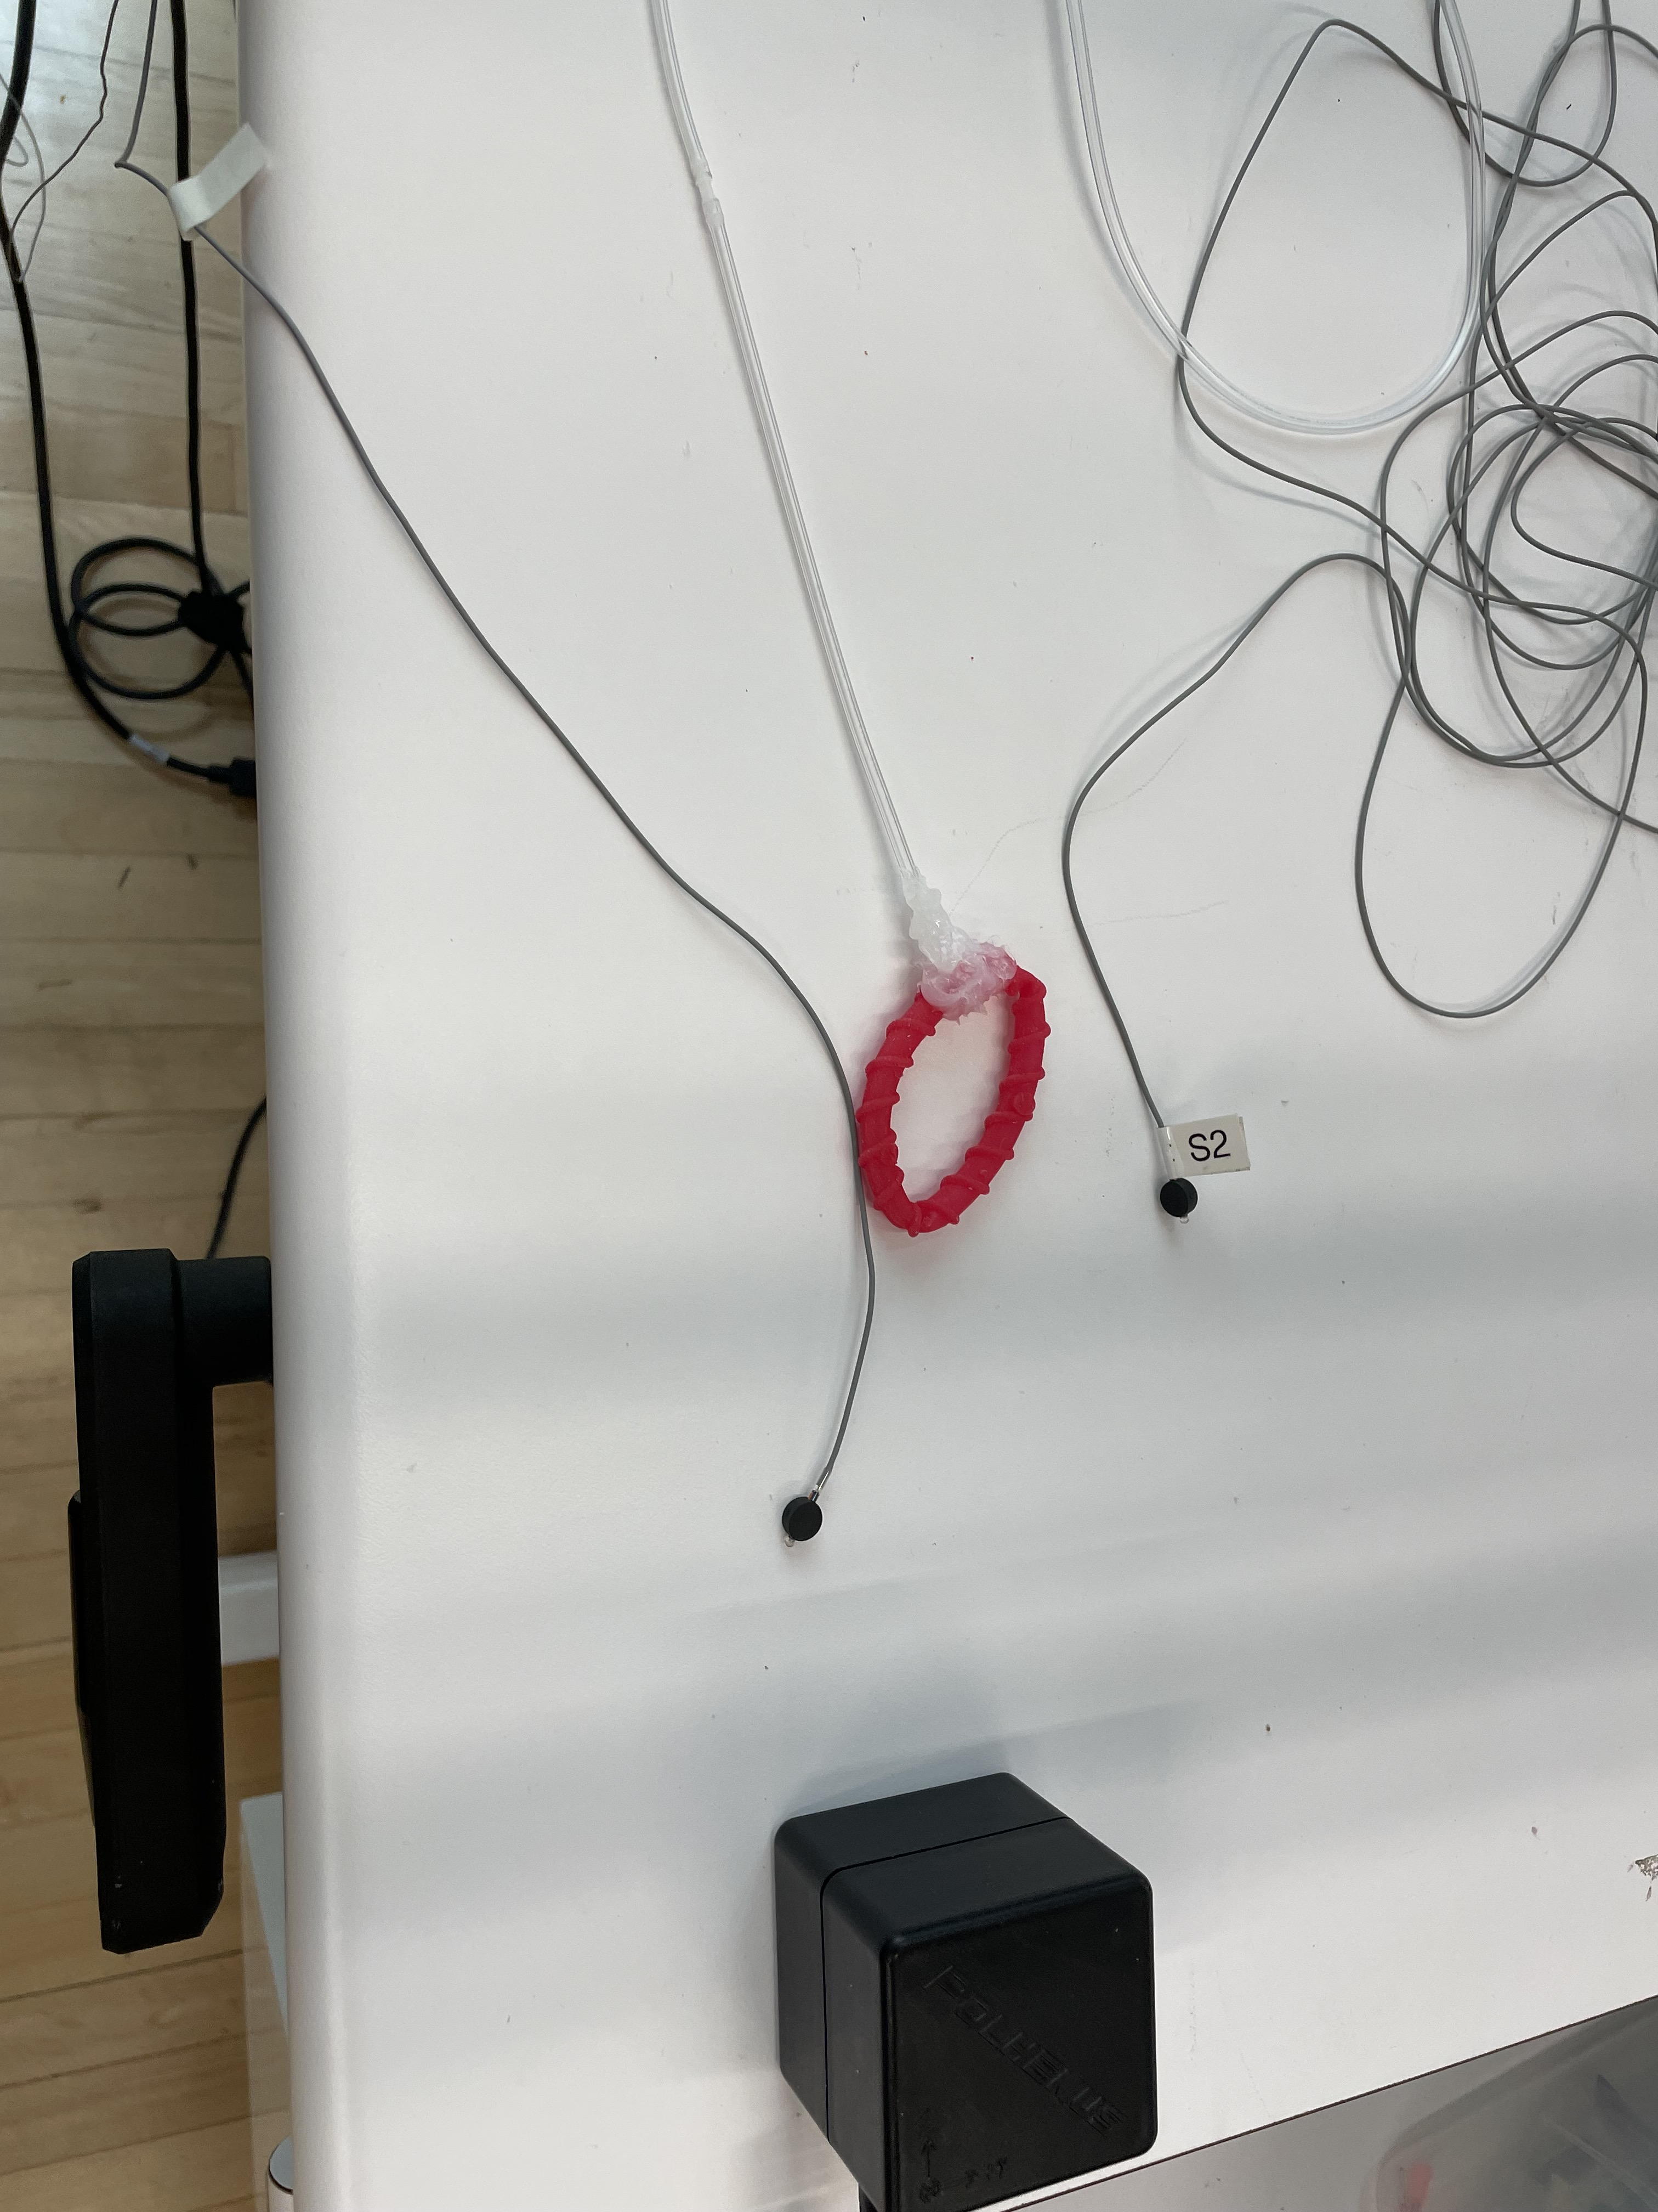

1. Ring Device and EM Sensors Prior to Testing

## Results

1. Trends of Displacement Based on Constraint Level

The collected data did not deviate wildly from theoretical projections for device displacement at varying levels of constraint. In fact, the actual data showed an improvement in performance than predicted in the simulations. However, contrary to initial projections, for rings with thinner walls, increasing the constraint level actually increased the ratio of meridional to nominal diameter. The thickest walled rings appear to display the downward trend from the simulations more accurately. However, there is a noticeable outlier with the blue ring, (75% on the thickest walls). This ring presented many problems with testing, having numerous air holes that wouldn’t stay patched, and a tendency to invert itself when being inflated. If this experiment were to continue, a new device for these parameters would likely need to be made and retested for more accurate results.

When comparing the ratio of change in diameter, the story is slightly less interesting.

1. Change in Displacement vs. Constraint Level (Differential)

This ratio remains far more constant across varying constraint levels than the simulations predicted they would (other than the blue ring outlier). Moving forward, the ratio of the change in meriodinal diameter to the change in nominal diameter is a metric that likely does not warrant additional consideration.

# CONCLUSIONS, AND RECOMMENDATIONS

Moving forward, additional testing may be required for thicker ring devices. The predicted trend of their diameter ratios with increasing constraints, especially because of the blue ring outlier, is largely unclear. For the other devices, it appears that less constrained devices actually improve the displacement ratio of interest. Overall, device performance demonstrated improvement over theoretical simulations. However, no evidence was present of a hidden sweet spot in the highest constraint levels that would yield a device with negligible meridional expansion. This unfortunately leaves many questions unanswered about the feasibility of an inflatable active silo ring, warranting further study.

Perhaps further work should go towards the design of a new ring that has yet to be considered. One idea could be to develop a ring that would be able to direct expansion in the nominal direction instead of the meriodonal plane. I included a rudimentary design of what that might look like. With a stronger outer layer keeping the outside diameter relatively constant, expansion would be directed inwards, focusing the pressure created within the ring to drive nominal expansion.

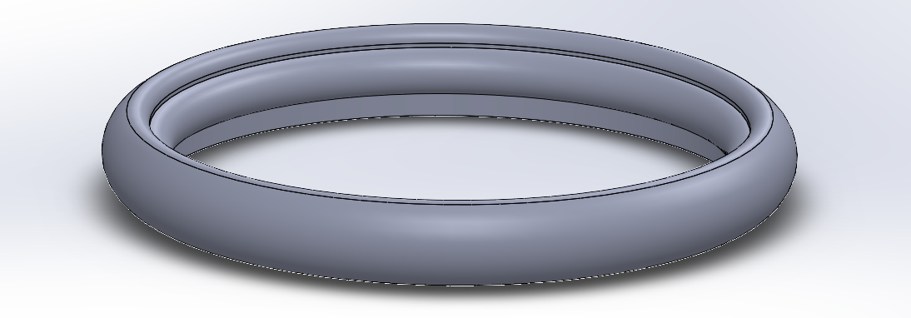

1. Potential New Ring Design

If further study will be conducted into these silo ring devices, time should be spent developing more reliable methods of inserting air tubing into the rings that would prevent holes reducing air pressure and ring effectiveness. The sealing process with Sil-Poxy is irregular and not easily repeatable with any degree of accuracy. A method that obviates a need for adhesives or incisions applied by hand would be essential if active baby silos were ever to be manufactured on a scale that would make them marketable.

Improvement in the method of testing the true geometric properties of the rings would be useful in future studies. Ideally, the EM sensors would have been used in this project for continuous data collection as the rings were inflated. However, the inability to affix the sensors to the rings without impeding the natural expansive properties of the ring forced discrete measurements to be taken with hand placed sensors. The pressure with which each ring was inflated to was also somewhat arbitrary. The rings were inflated to a pressure that was assumed to be close to failure, but this was determined solely from observation. If continouous sensing was being used, air pressure should be added to the device until the device bursts in order to measure the diameters of the ring at the moment immediately before failure.

Outside of the scope of this experiment, investigation should be taken into the ability of silicone rings to maintain their structural integrity during inflation over a long period of time. There would be a concern of fatigue and plastic strain deformation in the rings themselves if they were to be held at an expanded state for the length of an infant’s gastroschisis treatment.

References

Hasheesh, A. A. E. & Elhalaby, E. (2011). “Evolution of Management of Gastroschisis.” *Annals of Pediatric Surgery,* 7, 10-15.

Kunz, S.N., Tieder, J. S., Whitlock, K., Jackson, J. C., Avansino, J. R. (2013). “Primary Fascial Closure Versus Staged Closure with sSilo in Patients with Gastroschisis: A Meta-Analysis.” *Journal of Pediatric Surgery.* 48, 845-857.

Ogasawara, Y., Okazaki, T., Kato, Y., Lane, G. J., Yamataka, A. (2009). “Spontaneous Sutureless Closure of the Abdominal Wall Defect in Gastroschisis Using a Commercial Wound Retractor System.” *Pediatric Surgeon International,* 25, 973-976. DOI 10.1007/s00383-009-2450-7

“Secrets of Arduino PWM.” (2022). *Arduino,* from <https://docs.arduino.cc/tutorials/generic/secrets-of-arduino-pwm>

Sherif, Emil. (2019). *Clinical Pediatric Surgery: A Case-Based Interactive Approach.* CRC Press.

“Silicone Silo Bags: For the Staged Reduction of Gastrochisis and Omphalocele.” *Specialty Service Products. Inc.* n.d. <https://ssp-inc.com/products/pediatric-products/silicone-silo-bag-with-wire-ring/>

Weinsheimer, R. L., Yanchar, N. L., Bouchard, S. B., Kim, P. K., Laberge, J. M., Skarsgard, E. D., Lee, S. K., McMillan, D., Dadelszen, P., The Canadian Pediatric Surgery Network. 2008. “Gastroschisis Closure – Does Method Really Matter?” *Journal of Pediatric Surgery,* 43, 874-87